Non-contact measurement of speed and length

The SPEETEC®: The sensor solution for materials moving in a linear path and special processes

Waldkirch, October 2020 – With the SPEETEC®, SICK is expanding its product range for speed and length measurement of objects moving in a linear path to include technology which measures directly on the material surface. The non-contact sensor is able to measure a wide range of web and continuous materials as well as blanks with an accuracy of just a few µm.
From a market perspective, the speed sensor closes the gap between tactile, indirectly measuring encoder solutions and laser velocimeters, which are often expensive to purchase and take a lot of effort to integrate and operate.
Look, but don’t touch: The sensor for special materials
For sensitive, soft or smooth surfaces, customers from factory or logistics automation require non-contact measurement options for the length, speed and position of continuous webs and blanks. Optical scanning prevents damage or contamination, thereby increasing product quality. The SPEETEC® offers a new way to measure without slip, without measuring elements or marking and without wear and tear on tactile sensor elements. Materials that cause wear, adhesion or abrasion damage to measurement solutions such as measuring wheel encoders, impairing their function, can be measured by the SPEETEC® with a high degree of process reliability and availability.
Safe and highly-accurate measurement principle
Since the SPEETEC® is equipped with class 1 lasers, the laser offers an alternative to expensive laser velocimeters and their costly protective measures. The return on investment (ROI) is particularly attractive. For the SPEETEC®, this is less than a year.
The non-contact measurement is performed with a laser Doppler process at speeds of up to 10 m/s. Two senders emit laser light – one in the direction of movement of the material, the other in the opposite direction. Since the two senders work independently of one another, possible mounting tolerances and surface fluctuations, for example with wavy surfaces, can be balanced out. All measurements are done with high precision: At a resolution of four micrometers, the accuracy relating to the object length of a meter is one millimeter. The repeatability in this case is specified with a half a millimeter. Measured values are output via the TTL or HTL interfaces common in the encoder world, making integration easy.
Better productivity while saving resources
With the SPEETEC®, length, speed and position can also be detected in linear movements when switching between forward and backward motions. In addition, acceleration measurement in applications with high motion dynamics is possible since, with the SPEETEC®, only three milliseconds pass between the start of the movement and the output of measured values. Comparable systems are much slower here. The speed sensor from SICK also creates new resource-saving solution options in the speed measurement of short materials. While velocimeters often require several meters of material feed, with the SPEETEC®, individual parts down to the size of a business card can be reliably measured.
Award-winning design: iF Design Award 2020
The rugged housing is designed for long-term use. Its shape and compact size characterize its high-quality design and enable integration into even the smallest spaces. The long window and the smooth edges indicate the measurement and mounting direction. These features impressed the jury of the iF Design Award. The SPEETEC® won the iF Design Award 2020 in the Product category.

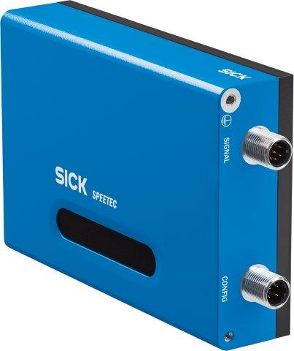
Slip-resistant, without measuring elements, without damaging sensitive surfaces and without wear and tear on tactile sensor elements – the SPEETEC® from SICK is an innovative, non-contact sensor for speed and length measurement of objects moving in a linear path.

Contact
Melanie Jendro │PR manager │melanie.jendro@sick.de
+49 7681 202 4183 │+49 151 741 035 31

SICK is one of the world’s leading producers of sensors and sensor solutions for industrial applications. Founded in 1946 by Dr.-Ing. e. h. Erwin Sick, the company with headquarters in Waldkirch im Breisgau near Freiburg ranks among the technological market leaders. With more than 50 subsidiaries and equity investments as well as numerous agencies, SICK maintains a presence around the globe. In the 2018 fiscal year, SICK had almost 10,000 employees worldwide and a group revenue of around EUR 1.6 billion.
Additional information about SICK is available on the Internet at http://www.sick.com or by phone on +49 (0) 7681 202 4183.

