Web width measurement with MLG-2 WebChecker light grid:

More precision and performance in packaging material processing

Waldkirch / Düsseldorf, September 2019 – With the MLG-2 WebChecker, SICK is launching a light grid for high-performance running edge detection as well as width and center measurement. It is used for the processing of web-shaped packaging materials – for example paper or plastic films in packaging processes. It is able to detect web width changes or deviations in the web position and report to the follow-up control system of the packaging machine in the same work process. This all happens with an accuracy of ± 0.3 mm and a resolution of 0.1 mm per web edge - so with extremely high precision.

The MLG-2 WebChecker is available in detection zones between 150 and 3,150 millimeters, within which the user can also monitor smaller formats without having to readjust sensors or reparameterize the light grid. The user has the choice between different sensitivities for different measuring tasks and surfaces properties, and can even detect semi-transparent products. The versatile connectivity concept, with its analog and digital outputs, different fieldbus connections and IO-Link, offers all modern automation engineering options.
Patented optical process enables precise measurement at close proximity
The patented cross beam technology developed by SICK as well as the powerful SIRIC® ASIC technology makes it possible to individually evaluate the up to 500 beams of the MLG-2 WebChecker and evaluate the light intensity of each beam through the web material at the same time – with a signal attenuation up to 20 percent for semi-transparent objects. In contrast to camera solutions where the illumination has to be placed further away from the surface, the measurement is done from a short distance away, making it more precise and reliable. Among others, this function is used to test the homogeneity of the material surface, to prevent material intake into a machine with double or multiple overlaps, or to ensure desired multiple layers of packaging materials when processing packaging.
Industry-compliant, integration-friendly and prepared for Industry 4.0 with IO-Link
Enclosure ratings IP67k and IP67, resistant sensor housing, optional protective screen and heater, specified operating temperatures between -30 °C and +55 °C – the MLG-2 WebChecker is equipped for use in challenging environments with its industry-compliant design. Clever brackets facilitate mounting of the light grid and ensure the highest degree of mounting flexibility. The versatile connectivity concept leaves nothing to be desired when it comes to automation engineering thanks to the RS485, analog interfaces and I/Os, fieldbus connections for EtherNet IP, PROFINET, EtherCat and PROFIBUS as well as IO-Link.

Ideal sensor solution for follow-up control systems
With its innovative technology, the MLG-2 WebChecker enables a high degree of product and process reliability especially in such processing machines in which, for example, web-shaped packaging materials are not led in straight for space reasons, but are instead deflected several times with the help of driven and passive rollers. For this reason alone, it cannot be completely ruled out that the material web may drift during the process. Potential disruptive factors also come into play here, such as a lack of concentricity in the rollers or swivel reels, changing inclinations in the guiding and deflection mechanics, the winding quality of the material on the coil, the preciseness of the positioning of the new reel after a reel change, potential slippage in the event of overrunning of rollers and reels, varying material properties within a web, or stretching effects as a result of web forces being exerted. All these influencing factors, whether occurring on their own or together, can disrupt the correct running of a web and cause it to drift.
Web running control systems are designed to guarantee stable web running through corrections in the machine with the aim of preventing creases in paper webs or ensuring perfectly adapted printing, punching and cutting processes, among other things. Edges are ideal reference variables in such overrun control systems because they can be detected with a high level of precision and reliability using suitable sensors such as the MLG-2 WebChecker light grid.

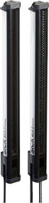 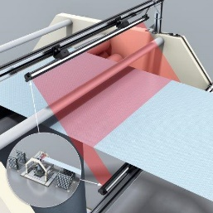 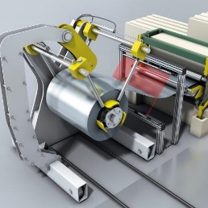
The MLG-2 WebChecker from SICK is a light grid for high-performance running edge detection as well as width and center measurement which can be used in the processing of web-shaped packaging materials, for example.

Contact
Melanie Jendro │PR manager │melanie.jendro@sick.de
+49 7681 202 4183 │+49 151 741 035 31

SICK is one of the world’s leading producers of sensors and sensor solutions for industrial applications. Founded in 1946 by Dr.-Ing. e. h. Erwin Sick, the company with headquarters in Waldkirch im Breisgau near Freiburg ranks among the technological market leaders. With more than 50 subsidiaries and equity investments as well as numerous agencies, SICK maintains a presence around the globe. In the 2018 fiscal year, SICK had almost 10,000 employees worldwide and a group revenue of around EUR 1.6 billion.
Additional information about SICK is available on the Internet at http://www.sick.com or by phone on +49 (0) 7681 202 4183.

