Reliable measurements of natural gas/hydrogen mixtures using SICK gas flow meters

Waldkirch, November 2021 - Renewable energy and green storage technologies are an important building block for future energy supply. The conversion of electricity from wind power plants or other environmentally friendly energy sources into hydrogen via electrolysis will play a significant role in this. The technology is expected to make significant inroads in the coming years – more than 20% hydrogen is expected to be fed into the gas networks very soon. This introduction of hydrogen poses great challenges and issues for the industry – for example how to reliably measure the hydrogen. The gas flow meters from SICK can deliver this reliability already.
In conjunction with experts at the DNV SE classification organization, the sensor manufacturer SICK conducted some tests using the existing measurement technology. The result: The ultrasonic technology from SICK makes it possible to reliably and safely measure the flow of hydrogen-methane gas mixtures up to admixtures of 30% hydrogen. SICK will therefore remain a reliable supplier of ultrasonic gas flow meters, even for hydrogen measurement.
Hydrogen is an important energy carrier of the future, firstly because it is easier to store and transport, and secondly because its applications are almost limitless, for example for operating vehicles, trains, ships and airplanes, in steel and cement production, as a fuel for turbines, or to heat buildings. Electricity from green sources such as hydropower or wind power will in future be converted into hydrogen by electrolysis. This will be transported to where the energy is required via the existing infrastructure, that is, by adding the hydrogen to the natural gas in the gas network. The mixture of gas and hydrogen will, as before, be transport via natural gas pipelines.
Many issues are currently being clarified through tests and pilot investments around the globe. How do we handle the significant changes in properties of the gas mixture? The results of an independent public test with SICK and important industry partners such as gas network operators, gas suppliers and municipal utilities – organized by the DNV SE – have shown that the new FLOWSIC600-XT gas flow meters safely and reliable measure the natural gas volumes in pipelines even at up to a 30% hydrogen fraction in the gas. This means that custody transfer measurement of natural gas containing hydrogen is possible using the FLOWSIC600-XT.
The results of the test confirm: The measurement technology from SICK ensures a highly accurate custody transfer measurement of natural gas volumes even for natural gas-hydrogen mixtures containing up to 30% hydrogen. To ensure an accurate custody transfer in existing gas networks as well, we recommend performing an initial assessment so that any necessary modifications to the existing meters can be carried out to ensure correct functioning.
SICK also offers the FLOWSIC600-XT sensor in one of two turnkey complete solutions for gas flow measurement: FLOWSKID, and the FLOWRUN flow metering system.

Images and image captions
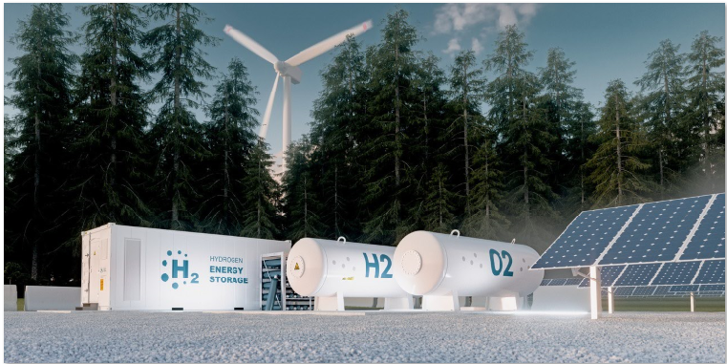
Hydrogen in the natural gas network: The existing gas flow meters from SICK measure this reliably.

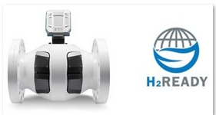
The FLOWSIC600-XT ensures a highly accurate custody transfer measurement of natural gas volumes even for natural gas-hydrogen mixtures containing up to 30% hydrogen.

Contact person
Melanie Jendro │PR Manager │melanie.jendro@sick.de
+49 7681 202-4183 │+49 151 741 035 31

SICK is one of the world’s leading solutions providers for sensor-based applications in the industrial sector. Founded in 1946 by Dr.-Ing. e. h. Erwin Sick, the company with headquarters in Waldkirch im Breisgau near Freiburg ranks among the technological market leaders. With more than 50 subsidiaries and equity investments as well as numerous representative offices, SICK maintains a presence around the globe. In the 2020 fiscal year, SICK had more than 10,000 employees worldwide and a group revenue of around EUR 1.7 billion. Additional information about SICK is available on the Internet at http://www.sick.com or by phone on +49 (0)7681202-4183.

