Distance sensor DT80: Maximum precision, even at great distances

Symbol-based sensor display for an intuitive user experience

Waldkirch, September 2023 – At the SPS 2023 (November 14 – 16, Hall 7A, Booth 340), SICK will present the new optical distance sensor DT80. Specified for ranges of up to 80 meters, the time-of-flight sensor stands out for its high accuracy and resolution. Thanks to a completely new usability concept, configuring the DT80 is quick and easy – via the symbol-based sensor display, the configuration software SOPAS, or an IO link. In this way, measuring speeds and other parameters can be easily calibrated. The sensor’s compact metal housing is perfect for applications with limited installation space, while IP65 and IP67 compliance allow it to be used under harsh conditions, even on a long-term basis. Integrated temperature compensation ensures high-precision, reliable readings, even when there are rapid temperature changes or in intensive sunlight.
Given the sum of its qualities, the DT80 opens up a range of new stationary and mobile application areas, e.g. in steel- and metalmaking, special-purpose and municipal vehicle manufacturing, mobile machines, port facilities and the consumer goods sector. Further, since its housing and connectivity concept are virtually identical to those of SICK’s other DT distance sensors, users can easily upgrade to the DT80 – for more precision and range – and take advantage of the product family’s tried and proven installation solutions.

Perfect precision

In many applications, the ability to precisely measure distances is essential to ensuring the accuracy of complex measuring and positioning tasks, consistent product quality, and maximum performance from machines and processes. With this aspect in mind, SICK developed the DT80, which, at ± 2 mm, delivers the highest measuring accuracy in SICK’s optical time-of-flight distance sensor portfolio. Further, its maximum resolution of 0.1 mm and high repeat accuracy underscore the distance sensor’s ambition to be best-in-class when it comes to precision. These improvements were achieved by using premium components and optimizing the already-impressive laser-based time-of-flight measurement. This makes the DT80 a high-precision distance sensor suitable for both stationary and mobile applications.

Detection at great distances

The DT80 is capable of reliably detecting natural objects with ca. 90 percent remission at up to 80 meters and measuring their distance from the sensor. Even for extremely dark surfaces with only six percent remission, the class-2 laser sensor offers a range of 14 meters. Taken together, these two qualities open a broad range of applications and make it possible to handle various combinations of distance and remission using the same type of sensor – which greatly simplifies procurement, warehousing and service availability for OEMs and users.

Future-oriented user experience

The DT80’s usability concept is called “Icons inside.” These elements, together with user-friendly menu navigation, allow the distance sensor to be intuitively calibrated and operated using the TFT color display. Alternatively, the DT80 can be precisely set up for the respective application via an IO link or using the SOPAS software – which now offers a new configuration interface. Four LEDs offer an even more straightforward overview of the sensor’s current status and settings.

Compact and durable

At only 65 mm x 33 mm x 57 mm (HxWxD), the DT80 is one of the most compact distance sensors on the market. As such, an “installation nook” can still be found for the sensor when the respective machine or vehicle offers very little space. Its standard cable connection also facilitates installation in close quarters. Thanks to the cast zinc housing, durable PMMA sensor window, IP65 and IP67 protection, and high specified shock and vibration resistance, the sensor can be permanently and reliably used even under harsh operating and environmental conditions, ensuring maximum productivity in stationary and mobile applications alike.

Industry 4.0-ready, thanks to its IO link

The DT80’s IO link allows – in addition to configuration – data to be transferred and exchanged between sensors, actuators and OT control systems. If a suitable IO-Link-Master with OPC UA is also used, data from the DT80 can be transferred via IO link and the Master, allowing it to be directly used in IT and cloud applications, e.g. for condition monitoring.

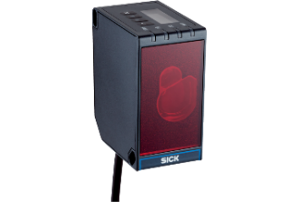
©SICK
The optical distance sensor DT80 with IO link from SICK stands out thanks to its impressive range, outstanding precision and intuitive user experience.
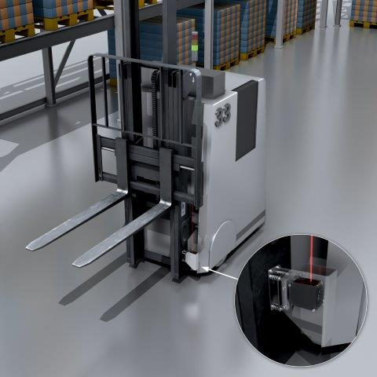
©SICK
Using the distance sensor DT80 to position the forks of a self-driving forklift offers a precise, reliable and efficient method. Here, the sensor reproducibly measures the exact height of the forks. This not only boosts operational efficiency and safety; it also paves the way for integration into automated processes and the recording of operational data for further use.

Contact partner:
Heike Malinowski │Public Relations Specialist │heike.malinowski@sick.de
+49 211 5301-146 │+49 160 5281 303

SICK is one of the world’s leading solutions providers for sensor-based applications in the industrial sector. Founded in 1946 by Dr.-Ing. e. h. Erwin Sick, the company with headquarters in Waldkirch, Breisgau near Freiburg ranks among the technological market leaders. With more than 50 subsidiaries and equity investments as well as numerous agencies, SICK maintains a presence around the globe. SICK has almost 12,000 employees worldwide and generated a group revenue of around EUR 2.2 billion in the 2022 fiscal year. Additional information about SICK is available at www.sick.com

