SICK authorizes Brinkmann Electronic Berlin for HIPERFACE DSL testing

Berlin company becomes conformity assessment body

Waldkirch/Berlin, March 2020 – Back in 2017, SICK STEGMANN GmbH (SICK) opened up the HIPERFACE DSL (HDSL) interface thereby making this globally applied standard accessible to all suppliers of motor feedback systems. SICK has now licensed the independent development services provider Brinkmann Electronic Berlin as a test laboratory. Manufacturers can now have their sensors subjected to a conformity assessment by Brinkmann.

To ensure the motor feedback systems from different manufacturers can be integrated into motors and drive systems without problems, these manufacturers must adhere exactly to the HIPERFACE DSL standard when developing their feedback sensors.

Before launching new sensors, manufacturers must now commission a conformity assessment by Brinkmann Electronic Berlin (BEL). BEL verifies that the HDSL standard has been adhered to, so that motor and controller manufacturers can be assured that the motor feedback systems with HDSL from different manufacturers will operate without problems. SICK, the licensor of the HIPERFACE DSL technology, has authorized the independent development services provider to do this testing. “We are pleased to have entered into a partnership with BEL, a company with longstanding experience in the areas of functional safety and HDSL, so that SICK can take the next logical step in opening up the interface and safeguarding the investment of users implementing HDSL”, explains Dr. Simon Brugger, Vice President Research & Development Motion Control Sensors at SICK AG.

As well as performing conformity assessments, BEL can also provide expert assistance with the implementation, diagnosis, as well as troubleshooting of malfunctions when implementing the HIPERFACE DSL® interface in a drive system. The introduction of conformity certificates will give users the certainty that HIPERFACE DSL products from different manufacturers can be combined without problems. Thanks to the licensing of the technology, trouble-free multi-vendor applications of HDSL products is assured. Thanks to testing and certification, long-term investment security is also achieved.

HIPERFACE DSL
HIPERFACE DSL complies with the RS485 standard and enables reliable data transfer between the drive and motor in servo drive systems. The data is transmitted via two wires which are directly integrated into the motor cable measuring up to 100 m in length. Electric drives featuring motor feedback systems and an integrated HIPERFACE DSL interface have a distinctive outward appearance with just one male motor connector. Hybrid cables that combine both servo and rotary encoder elements are becoming increasingly popular. These also carry signals from other sensors that are integrated into the digital motor feedback protocol. Special processes and the application of pulse transformers ensure that the encoder signal is decoupled from the faults in the motor power cable.

HIPERFACE DSL supports the functionality of the electronic type label for automated drive configuration. Motor specifications, serial numbers, part numbers, and other data are stored here and used to adjust the drive to the motor parameters automatically and when servicing is required.

Images: 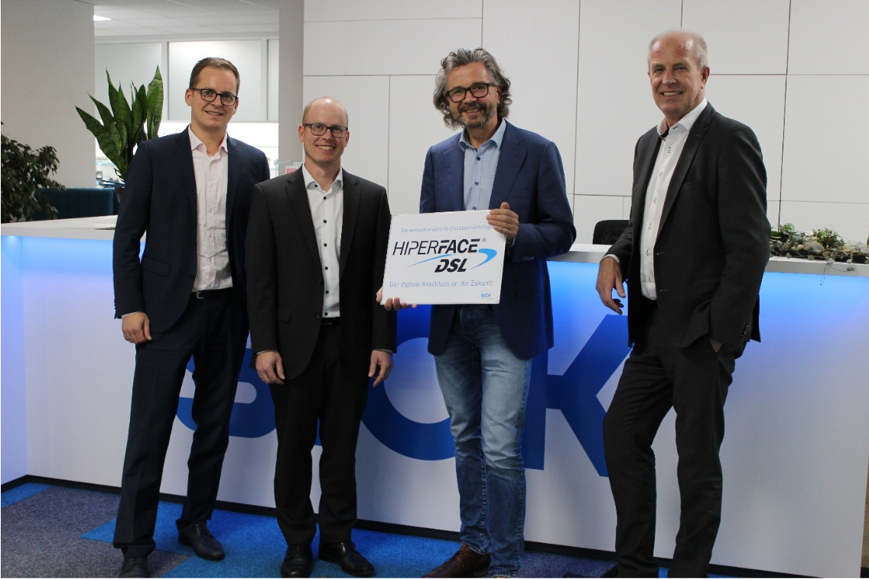
Image caption: Ready for HDSL testing: from left: Andreas Lautemann (SICK), Simon Brugger (SICK), Peter Brinkmann (Brinkmann), Bernd Appel (SICK)

Contact
Melanie Jendro │PR manager │melanie.jendro@sick.de
+49 7681 202 4183 │+49 151 741 035 31

SICK is one of the world’s leading producers of sensors and sensor solutions for industrial applications. Founded in 1946 by Dr.-Ing. e. h. Erwin Sick, the company with headquarters in Waldkirch im Breisgau near Freiburg ranks among the technological market leaders. With more than 50 subsidiaries and equity investments as well as numerous agencies, SICK maintains a presence around the globe. In the 2018 fiscal year, SICK had almost 10,000 employees worldwide and a group revenue of around EUR 1.6 billion.
Additional information about SICK is available on the Internet at http://www.sick.com or by phone on +49 (0) 7681 202 4183.

