SICK and Microsoft have a vision of the future
Both technology companies combine their strengths in 3DToF technology

Waldkirch, Germany, September 22nd, 2020 - SICK AG (SICK) is working with Microsoft Corp. (Microsoft) to enable the development of commercial industrial 3D cameras and related solutions, which will be compatible with a Microsoft ecosystem built on top of Microsoft depth, Intelligent Cloud, and Intelligent Edge platforms. Selected customers are already testing SICK cameras that incorporate Microsoft ToF depth technology.
Industrial cameras, based on technologies such as active and passive stereo, as well as 3D time-of-flight (3DToF), have been part of SICK’s standard portfolio for almost five years. Customers from various industries use the so-called 3D snapshot cameras from SICK for fast and, above all, robust and reliable acquisition of distance images and information derived upon this data. The company thus has both extensive technological, and market and application know-how to build and develop advanced 3D cameras suitable for industrial use.
Microsoft has the most extensive know-how and expertise in 3DToF measurements, with its intelligent depth technology currently being offered as part of the HoloLens mixed reality device and the Azure Kinect Development Kit.
SICK and Microsoft are working together to further expand 3DToF technologies in the context of Industry 4.0, to bring state of the art technologies to SICK’s 3DToF Visionary-T camera product line, and make it smarter, using Azure Intelligent Cloud and Intelligent Edge capabilities. Both companies are combining their strengths and make use of the resulting synergies. "By constantly improving and developing new 3D camera solutions we aim to remain the technology leader. Cooperations with companies such as Microsoft accelerate an implementation and, above all, are more cost-effectively for our customers", says Dr. Robert Bauer, Chairman of the Executive Board of SICK AG.
SICK’s latest industrial 3DToF camera Visionary-T Mini is expected to be available for sales in early 2021, while prototypes are already available now. Visionary-T Mini incorporates another variant of Microsoft’s 3D ToF technology with an impressive dynamic range and a resolution of ~510 x 420 pixels. It will offer extended performance and advanced on-device processing infrastructure and tools not currently available with Azure Kinect DK, to include, but not limited to: 24/7 robustness, industrial interfaces, enhanced resolution with sharper depth images and enhanced depth quality.
Customers interested in SICK’s 3DToF cameras, are encouraged to get in contact with their local SICK subsidiary (sick.com).

About the 3DToF Technology
3DToF is the measurement of the time of flight of light pulses between the camera and the target scene simultaneously for each pixel of the image. As soon as the arrival time or phase shift of the reflected light is known, the distance to the object can be determined and a distance image is created. As a 3D snapshot technology, 3D time-of-flight can capture a scene three-dimensionally even if it is static and without the necessity of actuators or mechanical parts inside the camera that have to move.

Pictures:
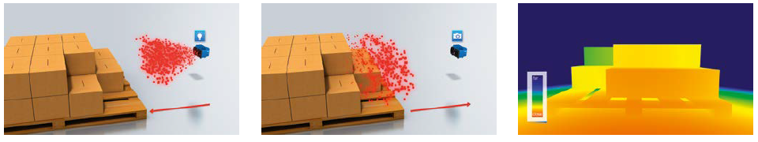
Caption: Principle of operation of 3D time-of-flight technology.

Contact
Melanie Jendro │PR Manager │melanie.jendro@sick.de
+49 7681 202-4183 │+49 151 741 035 31

SICK is one of the world's leading solution providers for sensor-based applications for industrial applications. Founded in 1946 by Dr.-Ing. e. h. Erwin Sick and headquartered in Waldkirch im Breisgau near Freiburg, the company is one of the technology and market leaders and is present around the globe with more than 50 subsidiaries and affiliates as well as numerous agencies. In fiscal year 2019, SICK employed more than 10,000 people worldwide and achieved Group sales of around EUR 1.8 billion. Further information on SICK is available on the Internet at http://www.sick.com or by phone at +49 (0)7681202-4183

