detec4 Smart Box Detection: intelligent solution for safe packaging machines

Safe human-material differentiation for cuboid conveyed objects

Waldkirch, November 2021 – Secondary packaging machines in the end-of-line area, top and side loaders, or sorter and ejector modules can now be operated in a safe and user-friendly manner: using the intelligent detec4 Smart Box Detection access protection system from SICK. With the help of a reliable pattern detection logic, it can safely differentiate rectangular objects such as cartons from persons and body parts in the inlet and outlet zones of packaging machines or intralogistic conveying systems. This allows the cartons to be transported continuously withouts stops into and out of fenced in machines. Since the safety solution requires no external process signals or muting sensors, it allows a cost-effective, flexible, compact, and maintenance-optimized machine design while also ensuring maximum operator safety.
The Smart Box Detection access protection system is the first intelligent solution of its kind on the market for reliable human-material differentiation. It is able to detect objects with a rectangular contour and measuring 13 cm or greater in height as they enter the constantly active detec4 protective field. An intelligent evaluation of the thereby interrupted light beam ensures a safe differentiation between humans and materials, because persons or body parts that walk over a conveying line or reach into a machine have a fundamentally different geometry and therefore create a significantly different beam interruption pattern. This reliably avoids erroneous safety stops of the conveying equipment.
Integration-friendly solution
The detec4 Smart Box Detection safety solution is characterized by its ease of integration. It can be integrated directly into the detec4 safety light curtain as supplementary functionality and requires no additional signals from automation systems or muting sensors during operation. It can therefore be integrated without any additional programming, mounting or wiring effort and configured to suit the requirements of the particular application. This lean solution design also markedly simplifies maintenance. If objects of different heights and lengths need to be detected in operation, it is not necessary to teach them in or adjust the configuration of the safety solution. This provides a maximum level of versatility and flexibility while ensuring the highest possible productivity of the system.

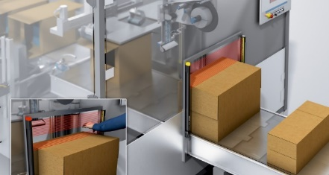
Images and image captions
The detec4 Smart Box Detection safety solution uses logic to reliably differentiate between humans and materials.

Contact person
Melanie Jendro │PR Manager │melanie.jendro@sick.de
+49 7681 202-4183 │+49 151 741 035 31

SICK is one of the world’s leading solutions providers for sensor-based applications in the industrial sector. Founded in 1946 by Dr.-Ing. e. h. Erwin Sick, the company with headquarters in Waldkirch im Breisgau near Freiburg ranks among the technological market leaders. With more than 50 subsidiaries and equity investments as well as numerous representative offices, SICK maintains a presence around the globe. In the 2020 fiscal year, SICK had more than 10,000 employees worldwide and a group revenue of around EUR 1.7 billion.

Additional information about SICK is available on the Internet at http://www.sick.com or by phone on +49 (0)7681 202-4183.

