Photo sheet: SICK AG, Sensor Intelligence Academy

Separate printable photo files; reprinting permitted

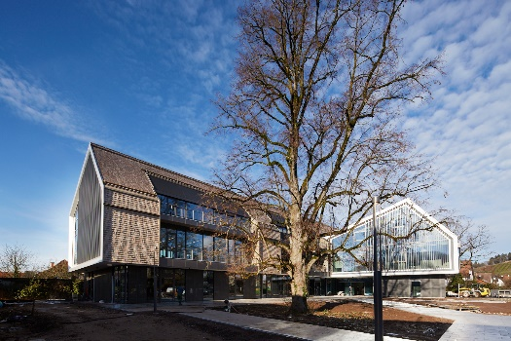 | Photo 1:  The Sensor Intelligence Academy – view from car park  Picture credit: Kai-Uwe Wudtke
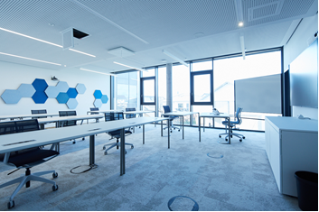 | Photo 2:  Example of modular training room with modern design  Picture credit: Kai-Uwe Wudtke
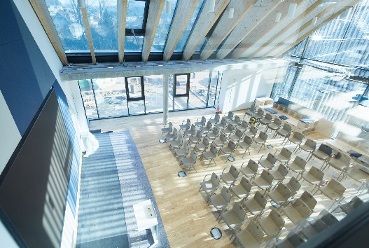 | Photo 3:  Auditorium with about 150 seats for information events on company and product developments on second floor  Picture credit: Kai-Uwe Wudtke
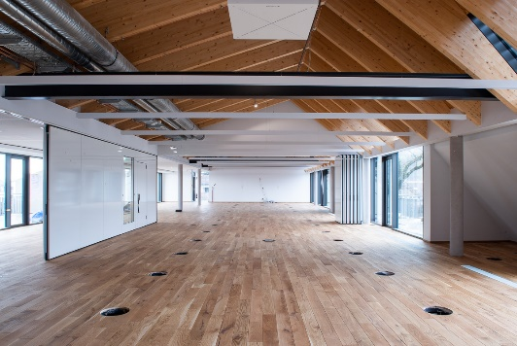 | Photo 4:  Co-creation area on third floor offering flexible use with up to 400 seats  Picture credit: Klaus Polkowski
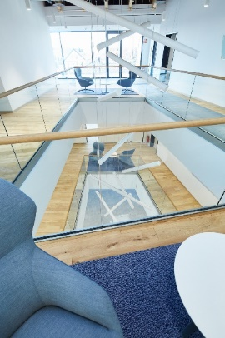 | Photo 5:  View of two-floor atrium suffused with light  Picture credit: Kai-Uwe Wudtke

