Dr. Mats Gökstorp

Member of the Executive Board Portfolio: Products & Marketing

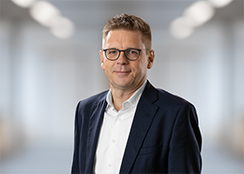
As a member of the Executive Board, Dr. Mats Gökstorp has been responsible for the Products & Marketing portfolio since 1 January 2021. He joined the company in 2003 with the acquisition of SICK IVP in Sweden and moved to Germany in 2007, becoming a member of the Management Board. He was also responsible for the global sales processes at SICK. He joined the Executive Board on 1 May 2013 with responsibility for Sales & Service.
Mats Gökstorp was born in Stockholm, Sweden, in 1965. After studying Computer Science and Engineering both in Sweden and the USA, he received his doctorate in 1995. He went into business with a small start-up company in 1993, where he worked in several positions in areas ranging from development to sales. By 2001, he had progressed to the role of General Manager, a position he held until 2007.
SICK is one of the world’s leading solutions providers for sensor-based applications in the industrial sector. Founded in 1946 by Dr.-Ing. e. h. Erwin Sick, the company with headquarters in Waldkirch im Breisgau near Freiburg ranks among the technological market leaders. With more than 50 subsidiaries and equity investments as well as numerous agencies, SICK maintains a presence around the globe. In the 2019 fiscal year, SICK had more than 10,000 employees worldwide and a group revenue of around EUR 1.8 billion. Additional information about SICK is available on the Internet at http://www.sick.com

